rawfile = os.path.join(data_dir,' blink_heartbeat_MEGEEG1_subj14_tsss_mc.fif')

Blink in ICA 000

Heartbeat in ICA 001

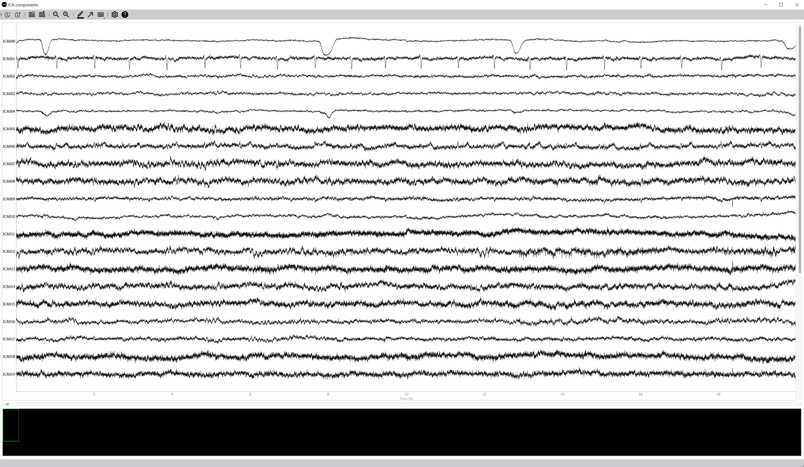

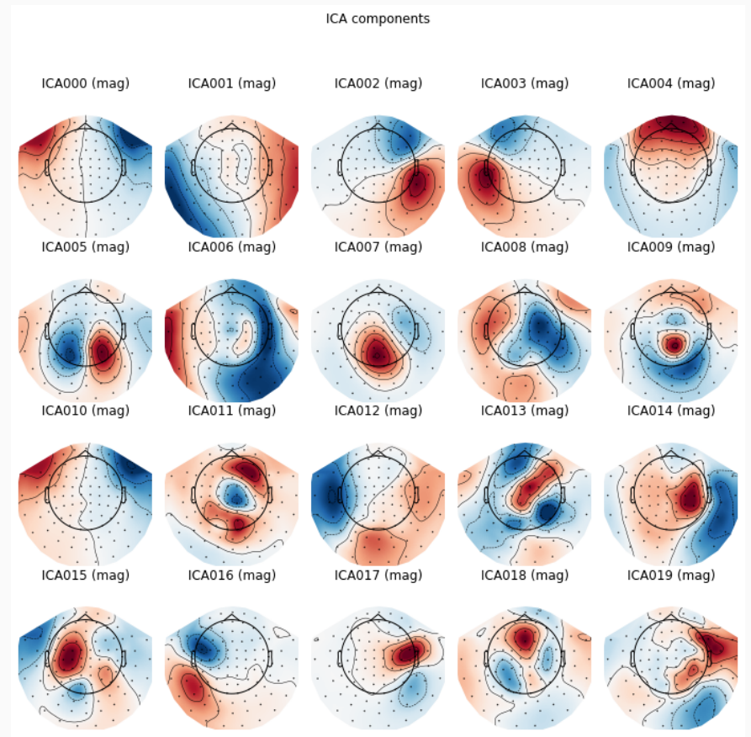

rawfile = os.path.join(data_dir,'subj04NN_sess01_raw_tsss.fif')

Blink in ICA 001

Heartbeat in ICA 010

